Overview
Applications: | Los
Background Information: | The business justification of this deployment is to make length of stay predictions based on clinical notes (Hist & Exam/Admission Notes). This version is purely written in python compared to the BW and STREAMBASE applications before this.
Changes involved | - Version 0.0.2: H&E notes for patients from ICU/HD will no longer trigger model predictions
Testing Scope | Tests includes previous regression tests as well as new ones (cases 4 & 5) for the new changes.
Tester: | Laksh
Date of Testing: | 11/04/2024

Test Results
No. | Test Item | Passing Criteria | Tester | Results
1 | Send the test files via the Staging simulator and check that the correct insertions take place in the database  Test cases (refer to https://bitbucket.org/nuhs-gcto/los-trigger-app/src/master/user_dir/testing/testFiles/live/simulator_files/ for actual files.):  1) H&E note (Pass)  2) Adm note (Pass)  3) Adm note with T11 (deletion as event trigger) (Fail)  4) H&E note from ICU/HD (Fail)  5) Adm note from ICU/HD (Pass) | - Proper db insertions (if pass, data should be inserted. If fail, then data should not be inserted)  Application doesn’t crash  - Application doesn’t crash | Laksh  11/04/2024 | PASSED

Test Results Screenshot

Before
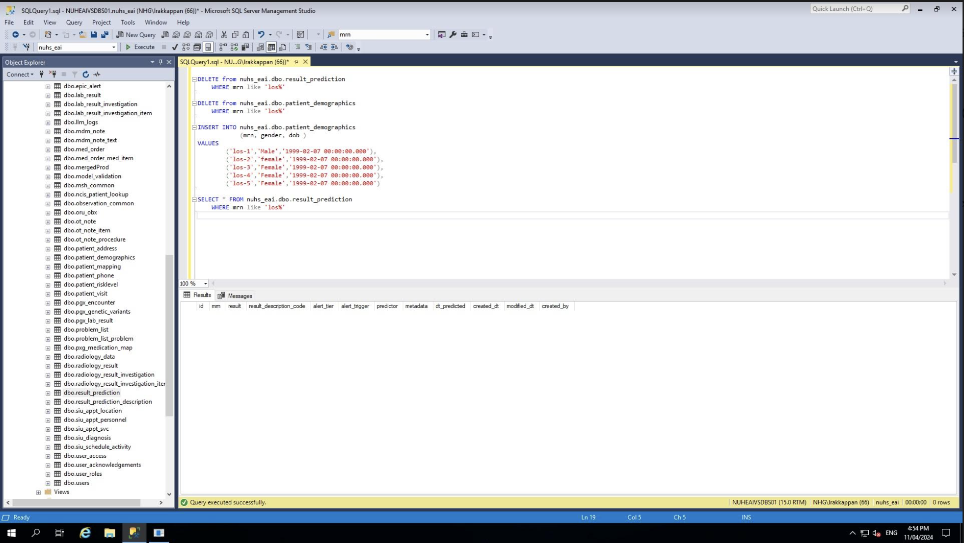

After test
